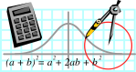  Rossmoyne SHS  Mathematics  Department | MATHEMATICS SPECIALIST 3CD | Semester 1 2010  EXAMINATION

NAME:
TEACHER: Mr Birrell Mr Whyte
Mr Longley

Section One:
Calculator-free

Time allowed for this section
Reading time before commencing work: 5 minutes
Working time for this section: 50 minutes

Material required/recommended for this section

To be provided by the supervisor
This Question/Answer Booklet
Formula Sheet

To be provided by the candidate
Standard items: pens, pencils, pencil sharpener, eraser, correction fluid, ruler, highlighters

Special items: nil

Important note to candidates
No other items may be used in this section of the examination. It is your responsibility to ensure that you do not have any unauthorised notes or other items of a non-personal nature in the examination room. If you have any unauthorised material with you, hand it to the supervisor before reading any further.

Structure of this paper

Section | Number of questions available | Number of questions to be answered | Working time (minutes) | Marks available
Section One:  Calculator-free | 7 | 7 | 50 | 40
Section Two:  Calculator-assumed | 13 | 13 | 100 | 80
 |  |  |  | 120

Instructions to candidates

1. Write your answers in the spaces provided in this Question/Answer Booklet. Spare pages are included at the end of this booklet. They can be used for planning your responses and/or as additional space if required to continue an answer.
  - Planning: If you use the spare pages for planning, indicate this clearly at the top of the page.
  - Continuing an answer: If you need to use the space to continue an answer, indicate in the original answer space where the answer is continued, i.e. give the page number. Fill in the number of the question(s) that you are continuing to answer at the top of the page.

2. Show all your working clearly. Your working should be in sufficient detail to allow your answers to be checked readily and for marks to be awarded for reasoning. Incorrect answers given without supporting reasoning cannot be allocated any marks. For any question or part question worth more than two marks, valid working or justification is required to receive full marks. If you repeat an answer to any question, ensure that you cancel the answer you do not wish to have marked.

3. It is recommended that you do not use pencil except in diagrams.

QUESTION | MARKS AVAILABLE | STUDENT MARK
1 | 6
2 | 5
3 | 4
4 | 15
5 | 3
6 | 3
7 | 4
TOTAL | 40

- [2,4 marks]
Differentiate the following and simplify.
  - 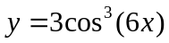

  - 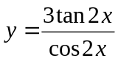

- [2,3 marks]
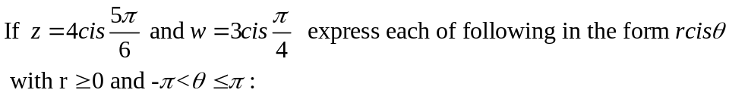
  - 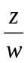
  - iz
- [4 marks]
Find the point of intersection between the three planes 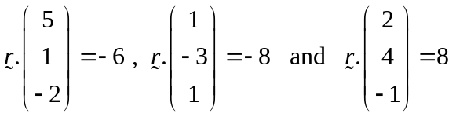.

- [2,3,2,4,4 marks]
Evaluate the following integrals:
  - 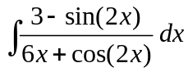
  - 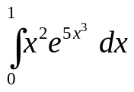
  - 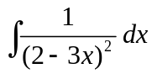
  - 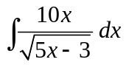 (Hint: use the substitution 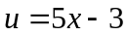)
  - 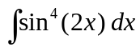
- [3 marks]
Find the real numbers m and n such that:
- [3 marks]
Use natural logs to solve 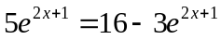 exactly.
- [4 marks]
Find the equation of the tangent to 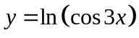 at the point 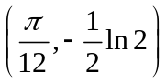.

Additional working space

Question number(s):

